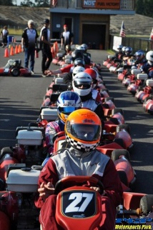
PNW Karting Challenge BREAKING NEWS!
Jackson Dean Construction has confirmed their participation as our matching funds sponsor for the PNW Karting Challenge!
- The first 15 registered teams (registration form & entry fee received) to submit donations of $1,000 will receive a $1,000 match.
- The next 5 teams to reach $2,000 in donations (previous matching funds not included) will receive an additional $1,000 match toward their overall total.
This is an INCREDIBLE opportunity that you don’t want to miss out on! Start collecting your team donations now with cash, check or through our online fundraising page with Razoo. Cash & check donations should be submitted as they are received so that we can track team fundraising totals for these matching funds. Plaques will also be awarded to the members of the highest earning team in the Challenge.

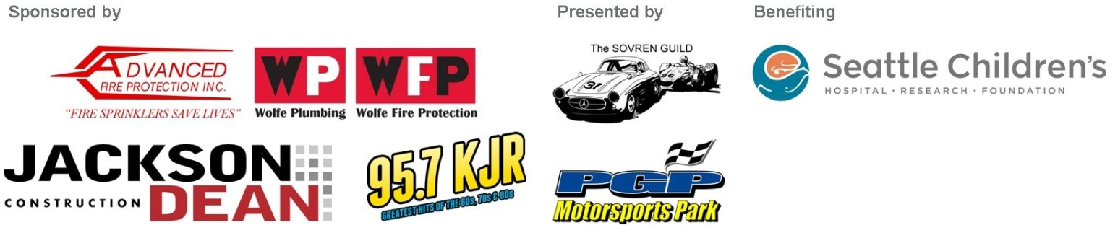
A huge thanks to Jackson Dean Construction for this matching sponsorship as well as to our premier sponsors Advanced Fire Protection and Wolfe Plumbing & Fire Protection, and our media sponsor KJR 95.7 FM!

